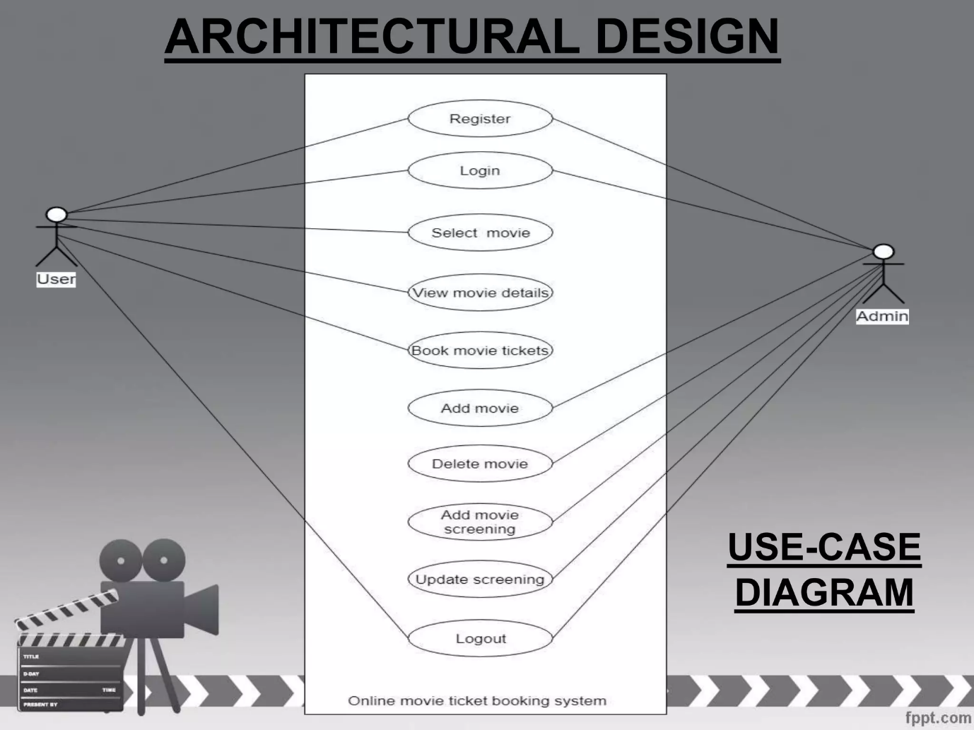

|  |  |
| --- | --- |
| **Register** |  |

**Role** **Task (Goal)** **Benefit**

1. As a user I want to signup for account So that I can login nexttime.

* User should able to enter Name, Phone no, Username, passcode & add accounts,location.
* After submitting details, he need to direct to login page.
* Estimation: 2 storypoints
* Priority: High

**LOGIN:-**

1. As a user I want to login to Account So that I can see the dashboard

* User should able to enter Username, Passcode.
* After Submit details, He need to get OTP for registered number.
* After Entering OTP he need to be authenticated.
* After authentication he need to direct to dashboard of user.
* User need to see the logout option as well.
* Estimation: 2 storypoints
* Priority: High

**Select movie & Book movie:-**

1. As a user I want to search different mov So that I can select mov based on requ

* User should able to filter movies based on dates.
* User should able to select movie in that particular theatre.
* User should able to select movie and number of tickets at that particular time if available.
* User should navigate to dashboard if he did not find his movie.
* Estimation: 3 storypoints
* Priority: High

1. As a Admin I want to add movie to site So that users can book there tickets.

* As a admin I should be able to see movie catalog, so that I can add movie.
* I should able to edit theatre for that movie at the particular timings.
* I can able to add that screens shows available.
* I can able to submit, so it reflect in frontend of application.
* Estimation: 3 storypoints
* Priority: High